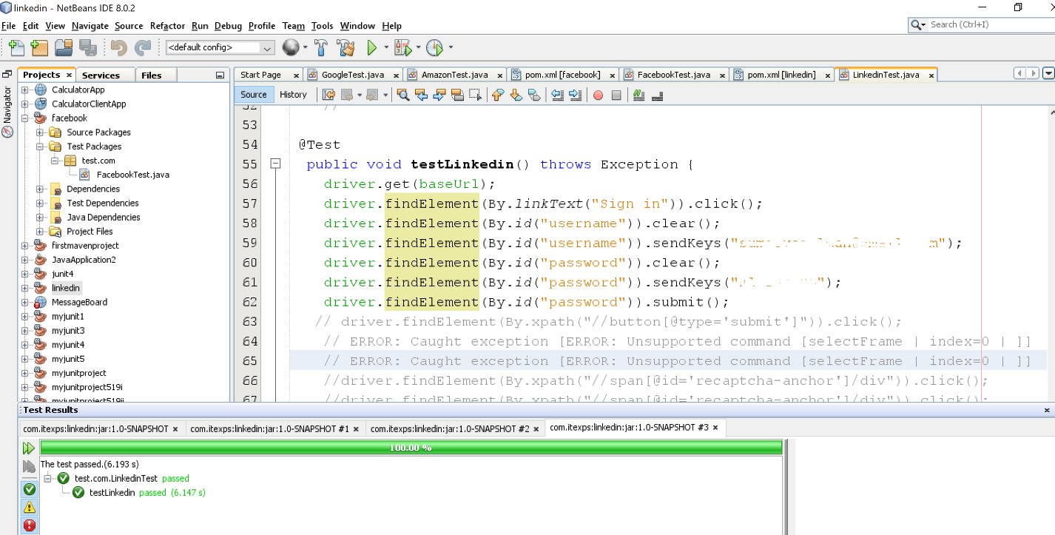

With the right credential it passed.

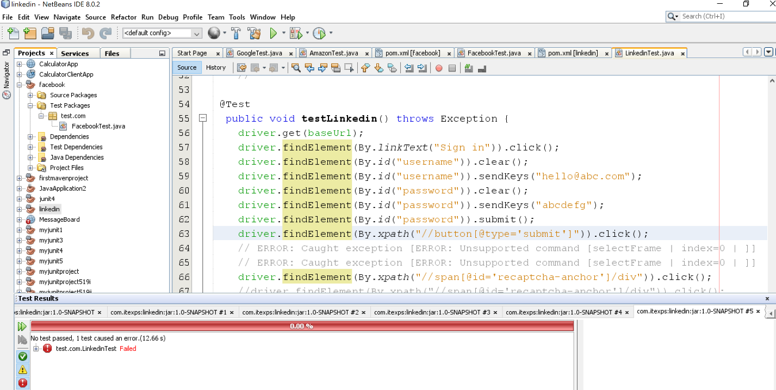

With fake credential it failed. Gets stuck at “I am not robot” page.

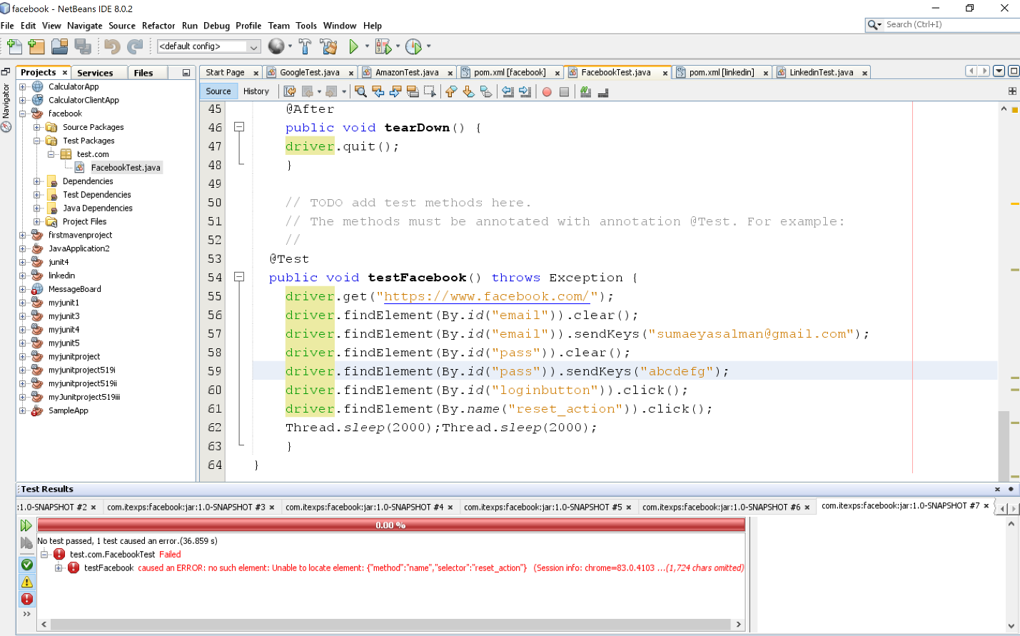

With fake credential it failed. After reset password button it gets stuck.

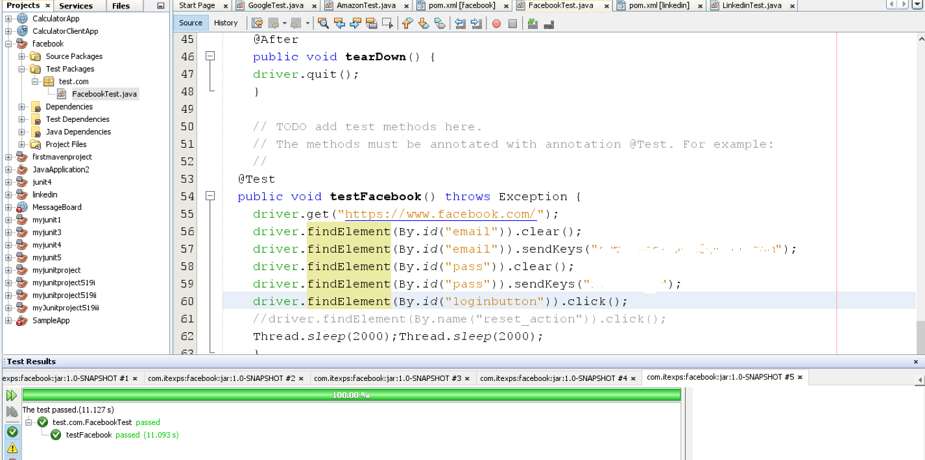

With right credential it passed!